**Windows Subsystem for Linux Installation Guide for Windows 10**

**1- Install the Windows Subsystem for Linux**

Before using Windows Subsystem for Linux, you must enable the “Windows Subsystem for Linux” optional feature. For this:

* Open PowerShell as an Administrator and type the command below.

Enable-WindowsOptionalFeature -Online -FeatureName Microsoft-Windows-Subsystem-Linux

* Restart your computer.

**2- Download and Install a Linux Distribution**

There are three ways to download & install a Linux Distribution:

* Microsoft Store
* Command-Line/Script ([read the manual installation instructions](https://docs.microsoft.com/en-us/windows/wsl/install-manual))
* Manually (for Windows Server – [instructions here](https://docs.microsoft.com/en-us/windows/wsl/install-on-server))

Downloading and Installing using the Microsoft Store

Please be sure that your Windows build is 16215 or later. You can [check your build from this link.](https://docs.microsoft.com/en-us/windows/wsl/troubleshooting" \l "check-your-build-number)

1. **Open Microsoft Store and select a Linux distribution. The following links are the related pages for each distribution:**

* [Ubuntu 20.04 LTS](https://www.microsoft.com/tr-tr/p/ubuntu-2004-lts/9n6svws3rx71?activetab=pivot:overviewtab)
* [Ubuntu 16.04 LTS](https://www.microsoft.com/store/apps/9pjn388hp8c9)
* [Ubuntu 18.04 LTS](https://www.microsoft.com/store/apps/9N9TNGVNDL3Q)
* [OpenSUSE Leap 15](https://www.microsoft.com/store/apps/9n1tb6fpvj8c)
* [OpenSUSE Leap 42](https://www.microsoft.com/store/apps/9njvjts82tjx)
* [SUSE Linux Enterprise Server 12](https://www.microsoft.com/store/apps/9p32mwbh6cns)
* [SUSE Linux Enterprise Server 15](https://www.microsoft.com/store/apps/9pmw35d7fnlx)
* [Kali Linux](https://www.microsoft.com/store/apps/9PKR34TNCV07)
* [Debian GNU/Linux](https://www.microsoft.com/store/apps/9MSVKQC78PK6)
* [Fedora Remix for WSL](https://www.microsoft.com/store/apps/9n6gdm4k2hnc)
* [Pengwin](https://www.microsoft.com/store/apps/9NV1GV1PXZ6P)
* [Pengwin Enterprise](https://www.microsoft.com/store/apps/9N8LP0X93VCP)
* [Alpine WSL](https://www.microsoft.com/store/apps/9p804crf0395)

**💡Tips:**

You can choose Ubuntu 20.04 LTS or Ubuntu 18.04 LTS

1. **After opening the distribution page, select “Get”.**

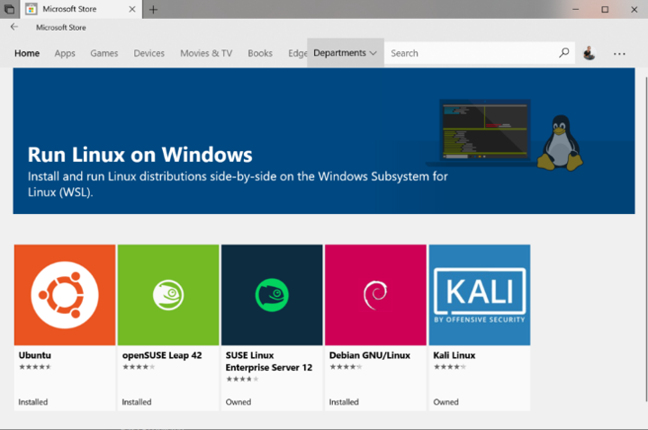

1. **Initialize your distribution**

After you install your Linux distro, you should [initialize the new distro instance](https://docs.microsoft.com/en-us/windows/wsl/initialize-distro) once, before it can be used.

**How to run Linux CENTOS 7 online without installing?**

There are several online options where you can run Linux distributions. In this tutorial, we will run Linux CENTOS 7 on the website <https://linuxzoo.net/>

With this online option, you can learn Linux using a remote Linux machine with root access in a very safe way.

**Step-1:** Open <https://linuxzoo.net/>

**Step-2:** Read the registering instructions

**Step-3:** Fill in the registration form

**Step-4:** Log in the system with your credentials

**Step-5:** After logging in, click “Join Queue” button

**Step-6:** In the control tab, Select “Linux CENTOS 7” and “fresh Linux install image” from the options and click the “Switch On” button

**Step-7:** You will see the machine state running and wait for the boot progress

**Step-8:** After the boot progress is completed, copy the link “Javascript VNC” and open that link in a new browser

**Step-9:** You will see Linux CENTOS has started and waiting for you to log in. The login credentials are:

username: Alice  
password: secure

**How to use Linux with Docker Container**

Linux can be run inside containers. The best practice to run linux is to use Docker. You can use Docker to run Linux Containers without installing Linux on your computer.

Before starting this tutorial, you should read the Docker documentation and install Docker. ([https://docs.docker.com](https://docs.docker.com/)). Be sure that your system supports running Docker.

After you have installed Docker, select one of the Linux images from Docker Hub ([https://docs.docker.com](https://docs.docker.com/))

The official images are strongly recommended to be used for base images. The most used Linux images are :

– ubuntu

– debian

– centos

– fedora

You can run Linux by running this command via your bash or any other supported CLI:

$ docker run -it -–rm <docker_image_name> bash

You can log out from the container with the “exit” command. To stop the container, you can run the following commands:

$ docker kill < docker_image_name >

$ docker rm –v < docker_image_name >

To remove all stopped containers run the following:

$ docker rm $(docker ps -a -q)

Formun Üstü

Formun Altı